**Parallel Processing:** These people are working in ***parallel***

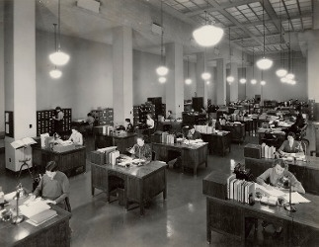

Parallel programs distribute their tasks to multiple processor, that actively work on all of them simultaneously.  
  
**Concurrent Processing:** This guy is ***concurrently*** juggling 8 balls. In Concurrent processing all the threads works to update a common resource. Ex: java.util.concurrent.atomic classes, Collections streams.



Concurrent programs handle tasks that are all in progress at the same time, but it is only necessary to work briefly and separately on each task, so the work can be interleaved in whatever order the tasks require.  
======================================================  
**Asynchronous processing:** This guy is ***asynchronously*** doing his laundry while reading



An asynchronous program dispatches tasks to devices that can take care of themselves, leaving the program free do something else until it receives a signal that the results are finished. Ex: Future in Java.